**Is it an acid or a base?**

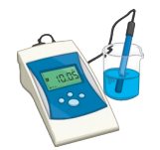

A pH probe can be used to get an accurate reading of pH from different liquids. An example of a pH probe is shown on the right.

A variety of solutions were tested, and the results are shown in the table below.

1. Complete the first column of the table by stating if the solution is an acid, base or neutral based on its pH.

|  |  |  |  |  |  |  |
| --- | --- | --- | --- | --- | --- | --- |
| Solution | pH | Acid, Base or Neutral? | Colour when adding | | | |
| Universal indicator | Bromothymol Blue | Methyl Orange | Phenolphthalein |
| Lemon juice | 2.2 |  |  |  |  |  |
| Milk | 6.8 |  |  |  |  |  |
| Orange juice | 3.2 |  |  |  |  |  |
| Tea | 5.2 |  |  |  |  |  |
| Oven spray | 12.5 |  |  |  |  |  |
| Toothpaste | 9.9 |  |  |  |  |  |
| Vinegar | 3.0 |  |  |  |  |  |
| Wine | 3.8 |  |  |  |  |  |
| Blood | 7.4 |  |  |  |  |  |
| Pure Water | 7.0 |  |  |  |  |  |
| Tomato juice | 4.4 |  |  |  |  |  |
| Dishwashing liquid | 5.5 |  |  |  |  |  |
| Carpet shampoo | 5.9 |  |  |  |  |  |
| Floor cleaner | 10.0 |  |  |  |  |  |
| Jif Cream Cleanser | 8.8 |  |  |  |  |  |

1. Using the diagram below, state the colour of each solution when each indicator is added.

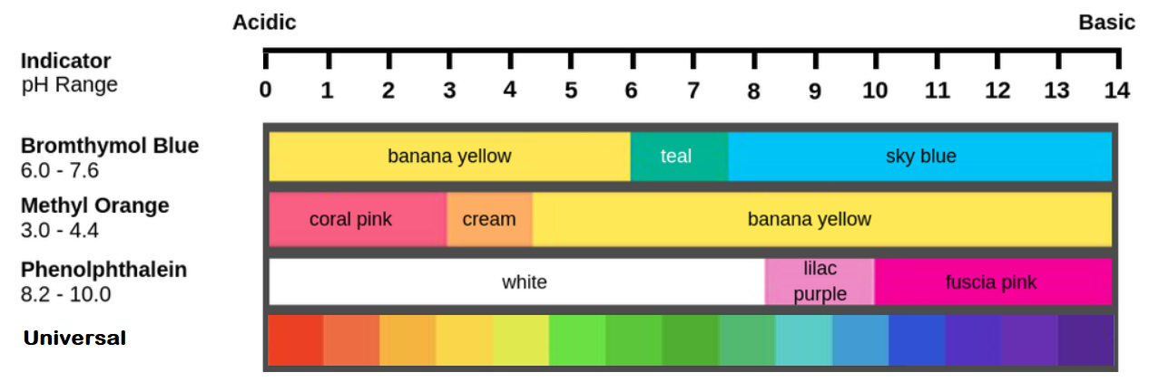

1. Give a reason why using a pH probe is a better way of determining a solution’s pH rather than using universal indicator.
2. Between each test, the probe should be dipped in pure water. Suggest a reason why.
3. What is an indicator?
4. Collect a sheet of A3 paper from the teacher and create a poster to show your understanding of common household acids and bases. Include on the poster:
   * Properties of acids
   * Examples of common acids
   * Properties of bases
   * Examples of common bases